**Pyspark__Assignment_Task3_Retail_DB_Analysis_by_Anup_Patil**  
  
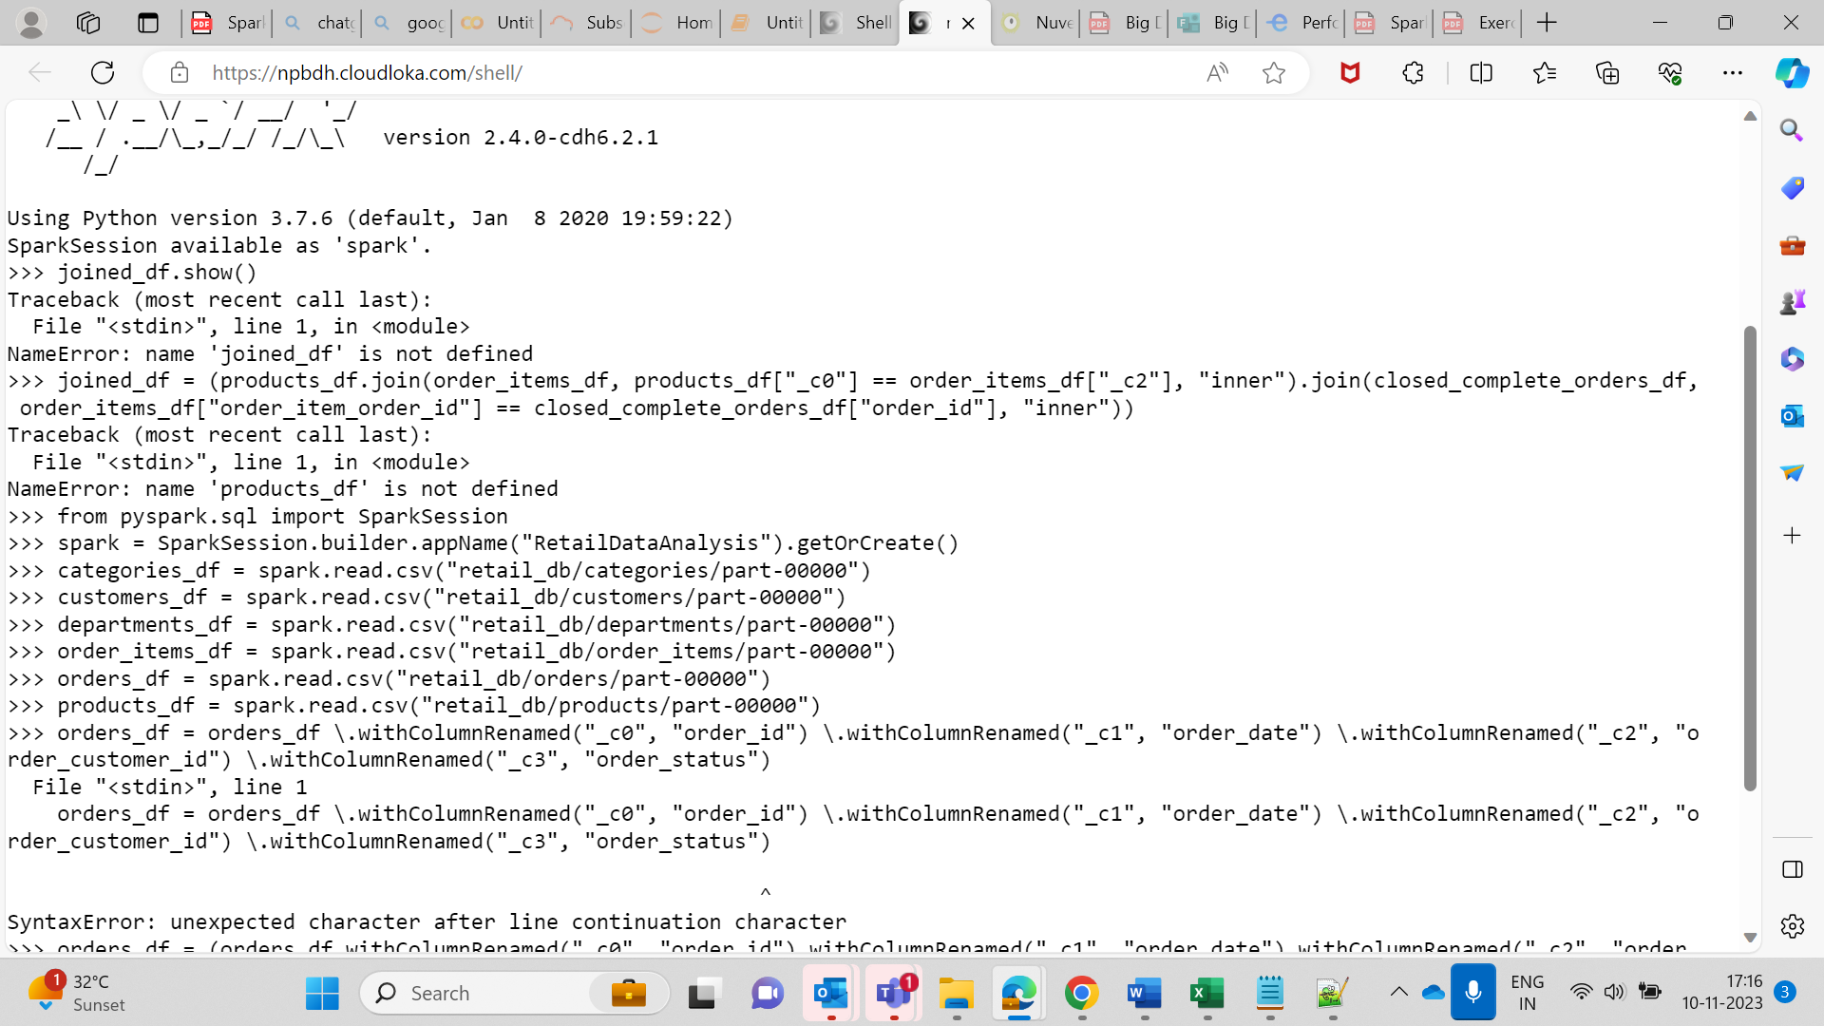  
  
  
**Q1 Get the count for each order status**  
  
  
order_status_count = orders_df.groupBy("order_status").count()

order_status_count.show()  
  
  
  
**Q2. only COMPLETE or CLOSED orders**

closed_complete_orders_df = orders_df.filter((orders_df["order_status"] == "COMPLETE") | (orders_df["order_status"] == "CLOSED"))

# Join the products, order_items, and closed_complete_orders DataFrames

joined_df = products_df.join(order_items_df, products_df["product_id"] == order_items_df["order_item_product_id"], "inner") \.join(closed_complete_orders_df, order_items_df["order_item_order_id"] == closed_complete_orders_df["order_id"], "inner")  
  
  
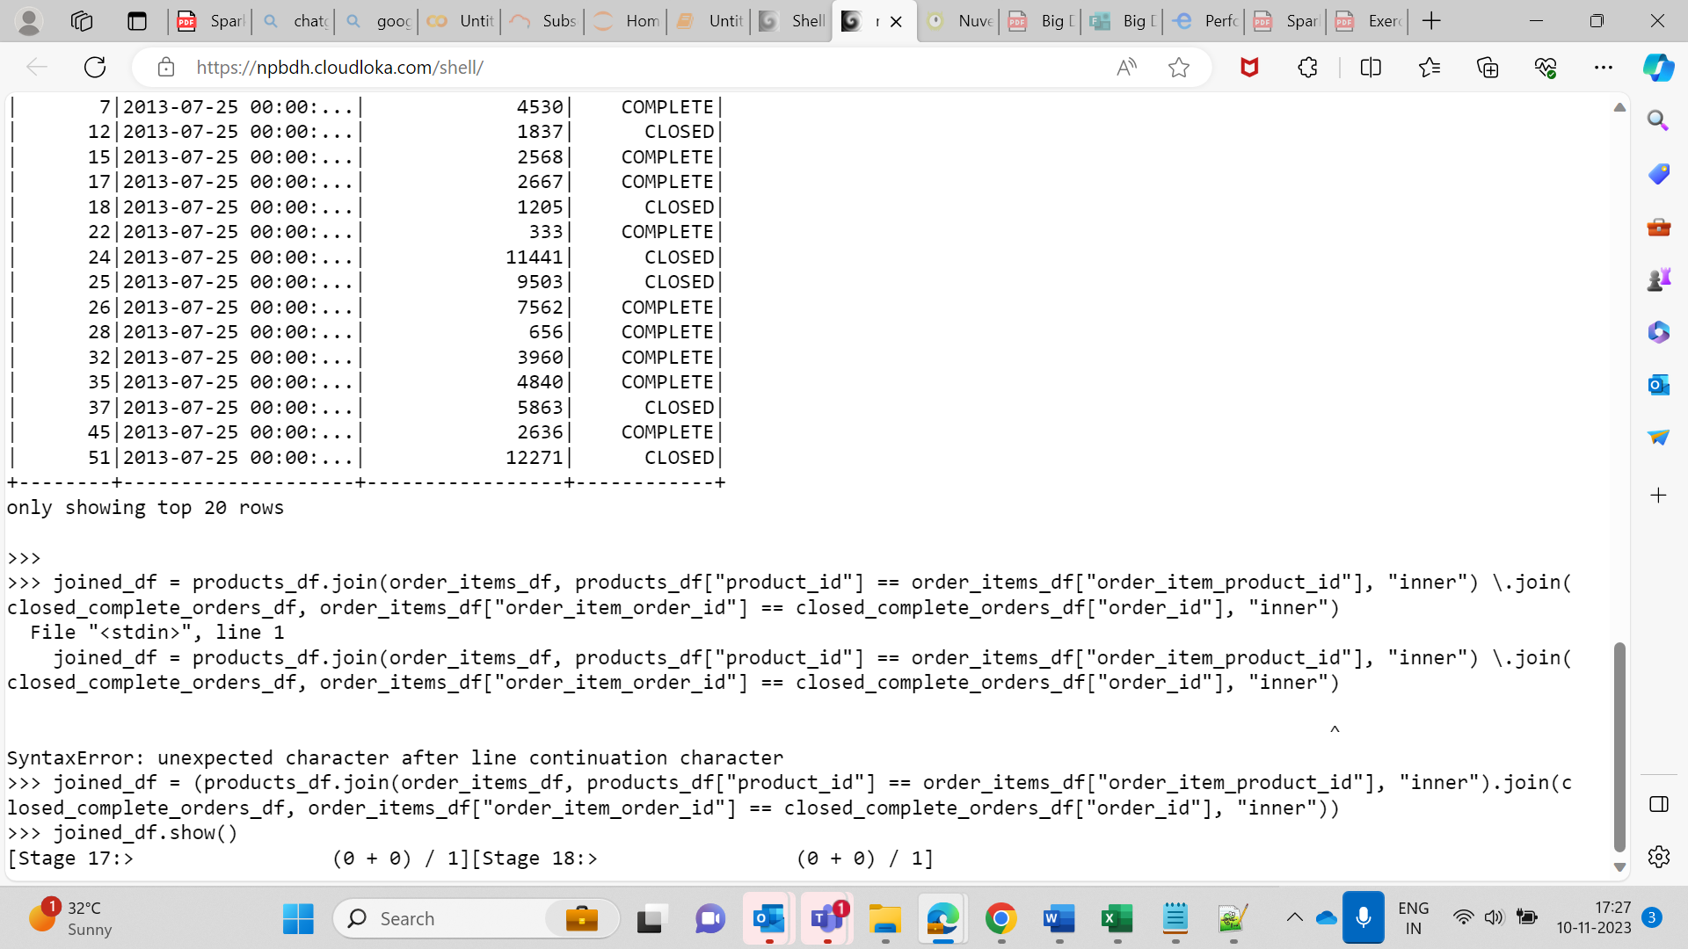  
  
  
**Q4.Calculate daily product revenue**

daily_product_revenue_df = (joined_df.groupBy("order_date", "product_id").agg({"order_item_subtotal": "sum"}).withColumnRenamed("sum(order_item_subtotal)", "daily_product_revenue"))  
  
  
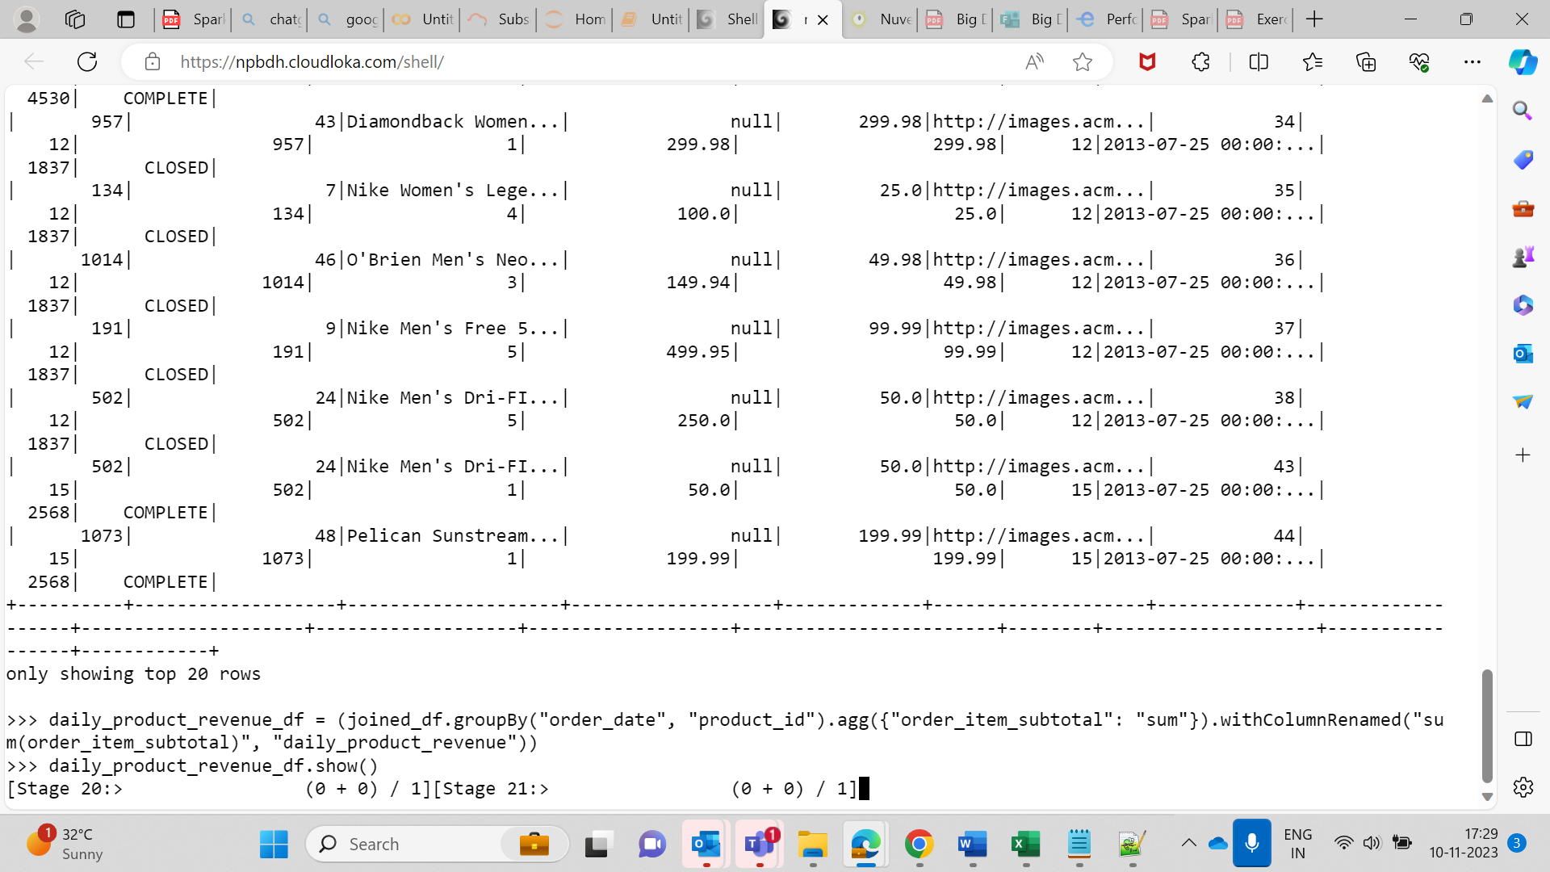  
  
  
**Create o/p Table as Hive**  
  
  
  
  
  
